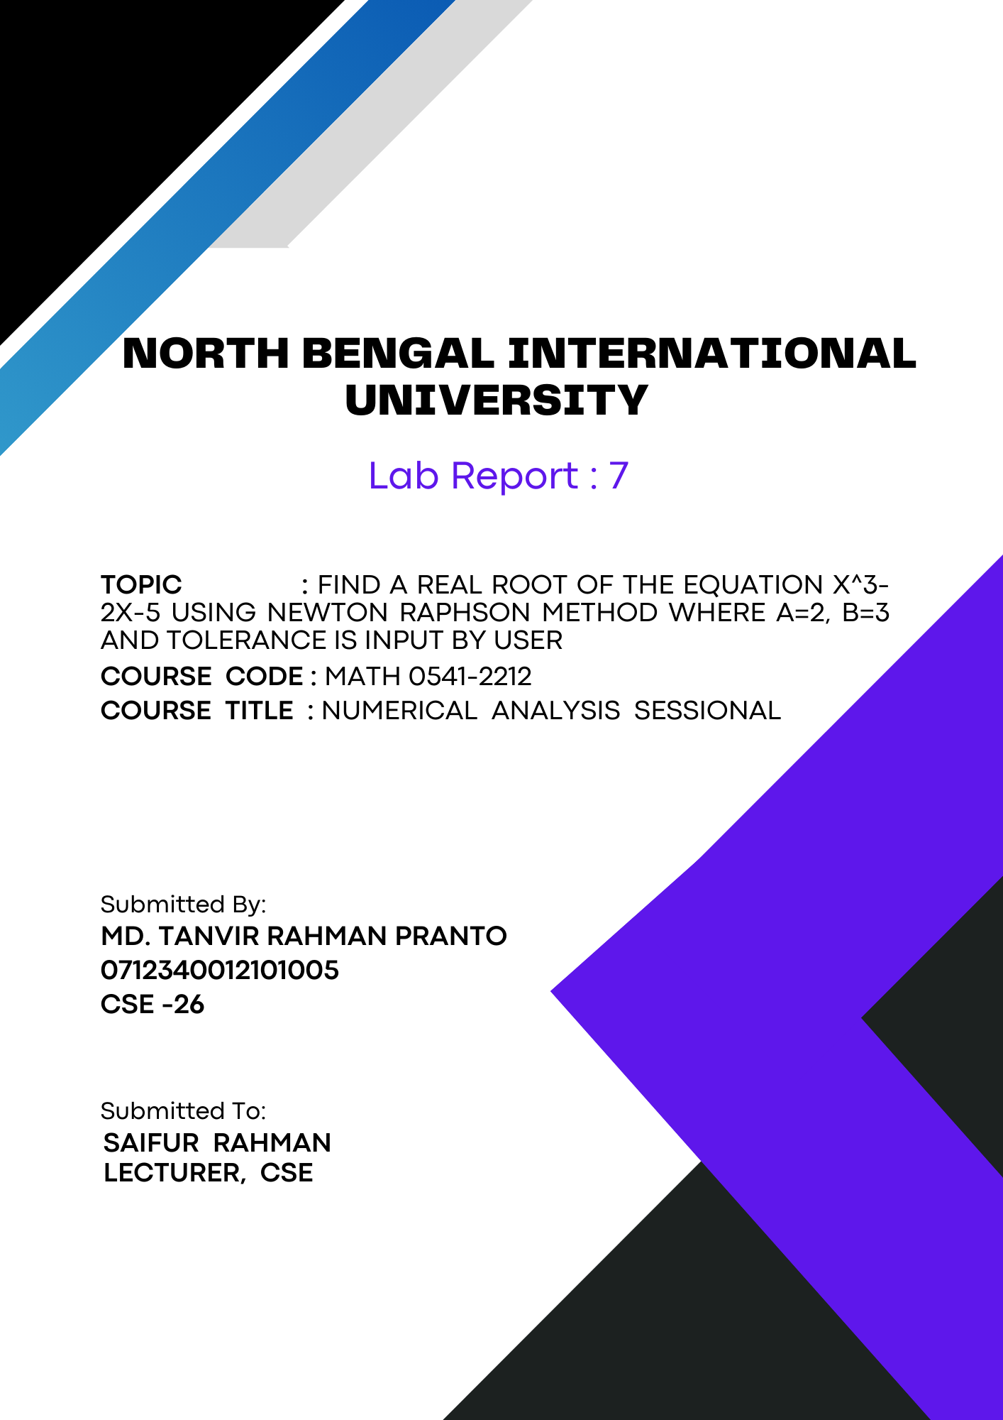
1

Find a real root of the equation x³-2x-5 using Newton Raphson method where a=2, b=3 and tolerance is input by user:

Theory of the Newton-Raphson Method:
The Newton-Raphson method is a powerful and efficient numerical technique for finding the roots of a real-valued function. It relies on the iterative application of a formula derived from the first-order Taylor series expansion of the function.
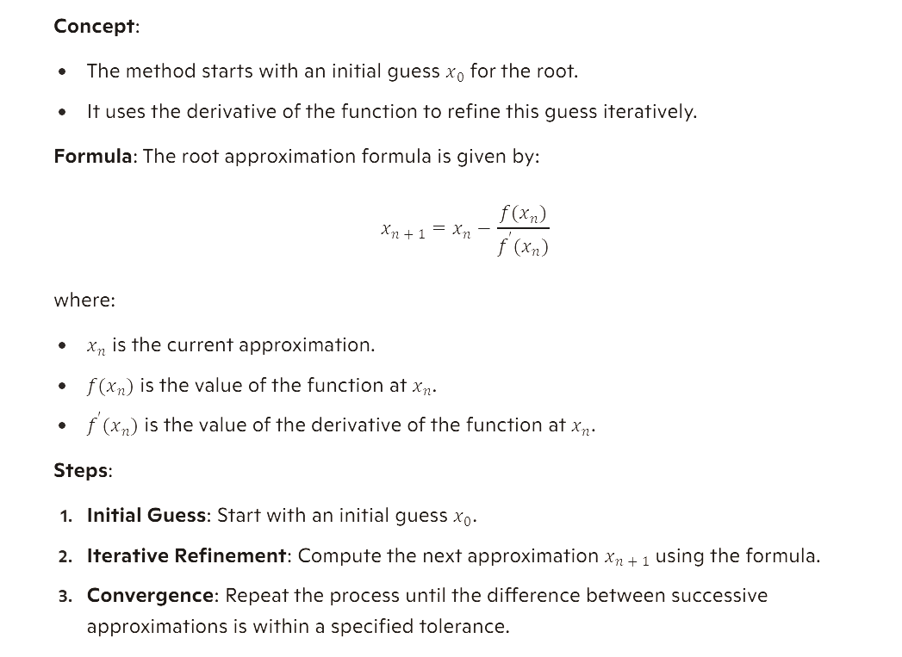

Algorithm:
Algorithm for Finding a Real Root of the Equation x^3 - 2x - 5 Using Newton-Raphson Method

1. Start
2. Define the function representing the equation:
- f(x) = x^3 - 2x - 5
3. Define the derivative of the function:
- f_prime(x) = 3x^2 - 2
4. Input the initial guess (x0) and the tolerance:
- Let x0 be 2.5 (between a = 2 and b = 3)
- Prompt the user to input the tolerance

5. Initialize the iteration counter:
- Set step = 0

6. Iterative process:
- While True:
- Calculate the new approximation: x1 = x0 - f(x0) / f_prime(x0)
- Increment the iteration counter: step = step + 1
- Print the current step and the new approximation: x1
- If the absolute difference between the new and previous approximation
(|x1 - x0|) is less than the tolerance, then:
- Break the loop
- Update the previous approximation: x0 = x1

7. Output the final result:
- Print the root: x1
8. End

Code:
import math
def f(x):
return x**3 - 2*x - 5

# Derivative of the function
def f_prime(x):
return 3*x**2 - 2

# Newton-Raphson method
def newton_raphson(x0, tol):
step = 0
while True:
x1 = x0 - f(x0) / f_prime(x0)
step += 1
print(f"Step {step}: x = {x1:.6f}")
if abs(x1 - x0) < tol:
break
x0 = x1
return x1

# Initial guess
x0 = 2.5 # Starting point between a=2 and b=3

# Input tolerance
tolerance = float(input("Enter the tolerance: "))

# Finding the root
root = newton_raphson(x0, tolerance)

print(f"The root is approximately: {root:.6f}")
Output:
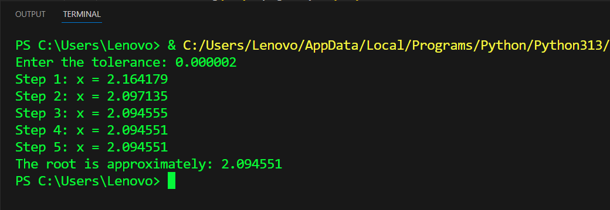

Conclusion: This Python code efficiently finds the real root of the equation x³- 2x -5 using the Newton-Raphson method. It iteratively refines the root estimate, ensuring rapid convergence. The structure ensures clarity and ease of use, making it an effective tool for root-finding.

